SIMATS ENGINEERING (SAVEETHA SCHOOL OF ENGINEERING)
Department of Computer Science and Engineering
ASSESSMENT TOOL 1 – Prompt Engineering Challenge

Course Code: | CSA65 | Course Title: | Generative AI and Large Language  Models
CO Assessed: | CO2 – Precision (BL1, BL2) | Assessment: | Assessment Tool 3 – Prompt Engineering Challenge
Weightage: | 40% of CIA | Total Marks: | 100 (2 Question)
CO1 Statement: | Apply prompt engineering techniques and utilize pre-trained Large Language Models through modern AI frameworks and APIs to solve real-world problems.(BL1, BL2)
Student Name: | C. Anu Keerthana | Reg. No.: | 192472057
Section / Batch: |  | Date:

Instructions to Students
•Answer 2 questions. Each question carries 50 Marks. Total: 100 Marks.
- Write clear, well-structured prompts and explanations where asked.
- Use your own original examples — do not copy from classmates or the internet verbatim.
- Where a diagram or worked example is requested, label it clearly.
- Illustrate prompting techniques (zero-shot, few-shot, chain-of-thought, role/system prompting, etc.) with concrete examples, not just definitions. Time allotted: 30 mins

Code of Conduct
I __________________C. Anu Keerthana(192472057)________ (Name / Reg No) certify that this submission is my original work and that I have adhered to the guidelines specified for this assessment. I understand that any violation of academic integrity rules will result in disciplinary action.
Signature of the Student: _____C. Anu Keerthana____________________

SECTION A – PROMPT ENGINEERING CHALLENGE

Q4. Role/Persona Prompt
Write a system prompt that turns the model into a "Socratic tutor" — one that never gives direct answers, only guiding questions, for a student asking about photosynthesis.
Q5. Structured JSON Output
Write a prompt that takes an unstructured recipe (in prose) and outputs it as valid JSON with keys: title, ingredients (array), and steps (array).

Q4. Role/Persona Prompt

Aim
To design a Role/Persona Prompt that makes the AI behave as a Socratic Tutor, guiding the student to understand photosynthesis by asking questions instead of giving direct answers.

Algorithm
- Import the required google.genai library.
- Create a Gemini client using the API key.
- Define a prompt assigning the AI the role of a Socratic Tutor.
- Instruct the AI to ask only guiding questions and not provide direct answers.
- Send the prompt to the Gemini model using generate_content().
- Display the generated response.
PYTHON CODE

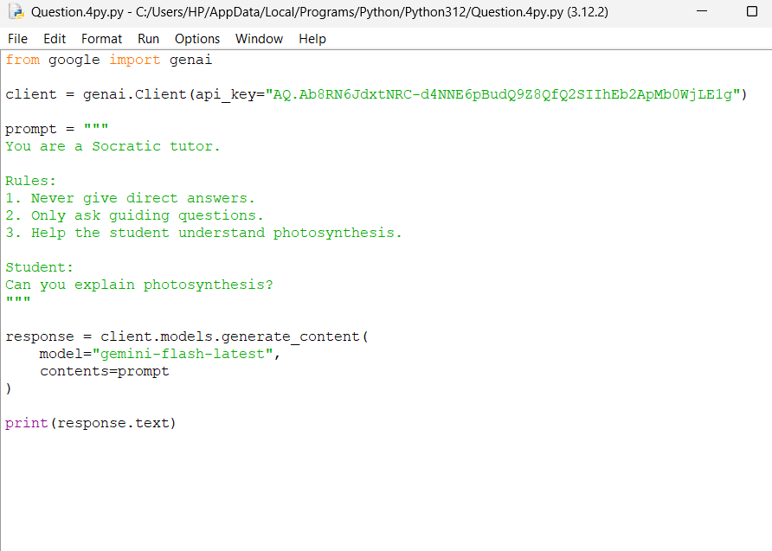

OUTPUT
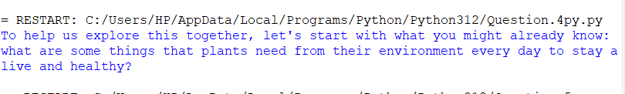
Result
The AI successfully acted as a Socratic Tutor, asking guiding questions to help the student understand photosynthesis without providing direct answers.

Q5. Structured JSON
Aim
To create a prompt that converts an unstructured recipe written in plain text into a valid JSON format containing the keys title, ingredients, and steps.

Algorithm
- Import the required google.genai library.
- Create a Gemini client using the API key.
- Store the recipe in plain text format.
- Create a prompt instructing the AI to convert the recipe into valid JSON.
- Send the prompt to the Gemini model using generate_content().
- Display the generated JSON output.

PYTHON CODE:
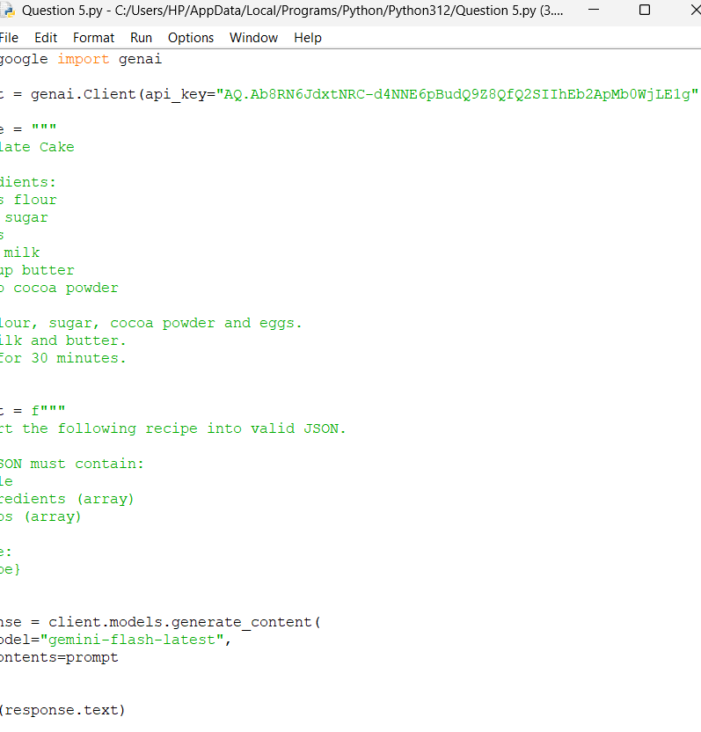

OUTPUT
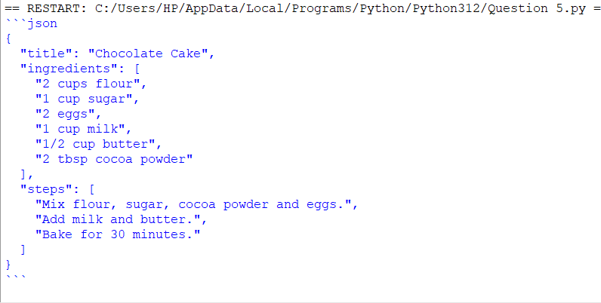

Result
The AI successfully converted the unstructured recipe into a valid JSON object containing the title, ingredients, and steps in the required format.

RUBRICS FOR CALCULATION

Criteria | Wt. | Level 4  (Exemplary) | Level 3  (Proficient) | Level 2  (Developing) | Level 1  (Beginning)
Technique  Selection | 30% | Correctly applies zero-shot/one-sh ot/few-shot & CoT technique appropriate to each task | Applies techniques with  minor mismatch to task | Limited understanding of which technique to use | Techniques applied incorrectly or not evident
Output  Effectiveness | 25% | Prompts produce accurate, task-appropriat e outputs across all assigned tasks | Prompts work well for most tasks | Prompts work for only a few tasks | Prompts are largely ineffective
Prompt  Craftsmanship | 20% | Prompts are  clear, specific, and reusable | Prompts are mostly clear | Prompts are vague or inconsistent | Prompts are poorly constructed
Prompt-Output  Documentation | 15% | Well-documente d  prompt-output pairs with clear rationale | Documented with minor gaps | Minimal  documentation  of  prompts/outputs | No rationale provided for prompt choices
Design Rationale | 10% | Clearly explains design choices  and iterations made | Explains most design choices | Limited explanation of process | No explanation of process provided

Marks Evaluation:
Question No. | Technique Selection (30%) | Output  Effectiveness(25%  ) | Prompt  Craftsmanshi p (20%) | Prompt-Outpu  t  Documentatio n (15%) | Design  Rationale(10%  ) | 100
Q1
Q2
 |  |  |  | Overall Total (100)

Faculty In-charge | Course Coordinator | Head of Department
Signature: _______________ | Signature: _______________ | Signature: _______________
Date: ___________________ | Date: ___________________ | Date: ___________________

